Practical no. 4
Name :- Danish Altaf Solkar Enrolment no. :-24111590805
Class :- CO3K – B Subject :- OOP
Aim :- To define a class Student having data members name and roll no. Accept and display data for one object.
Program :-
#include<iostream.h>
#include<conio.h>
class Student
{
public:
int roll_no;
char name[30];
void accept()
{
cout<<"\nEnter your name:- ";
cin>>name;
cout<<"\nEnter your roll no. :- ";
cin>>roll_no;
}
void display()
{
cout<<"\nYour name:- "<<name;
cout<<"\nYour roll no. :- "<<roll_no;
}
};

void main()
{
Student s1,s2;
clrscr();
s1.accept();
s1.display();
s2.accept();
s2.display();
getch();
}
OUTPUT:-
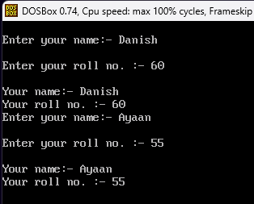

Aim :- To define a class Room with data members length, breadth and height. Member function area() and volume().
Program :-
#include<iostream.h>
#include<conio.h>
class Room
{
public:
float l,b,h;
void area()
{
float area=l*b;
cout<<"\nArea of room:- "<<area;
}
void volume()
{
float vol=l*b*h;
cout<<"\nVolume of room:- "<<vol;
}
};

void main()
{
Room r1;
r1.l=7.456;
r1.b=8.345;
r1.h=9.876;
clrscr();
r1.area();
r1.volume();
getch();
}
OUTPUT:-
